**Scenario 1:** The bank needs to process monthly interest for all savings accounts.

* + **Question:** Write a stored procedure **ProcessMonthlyInterest** that calculates and updates the balance of all savings accounts by applying an interest rate of 1% to the current balance.

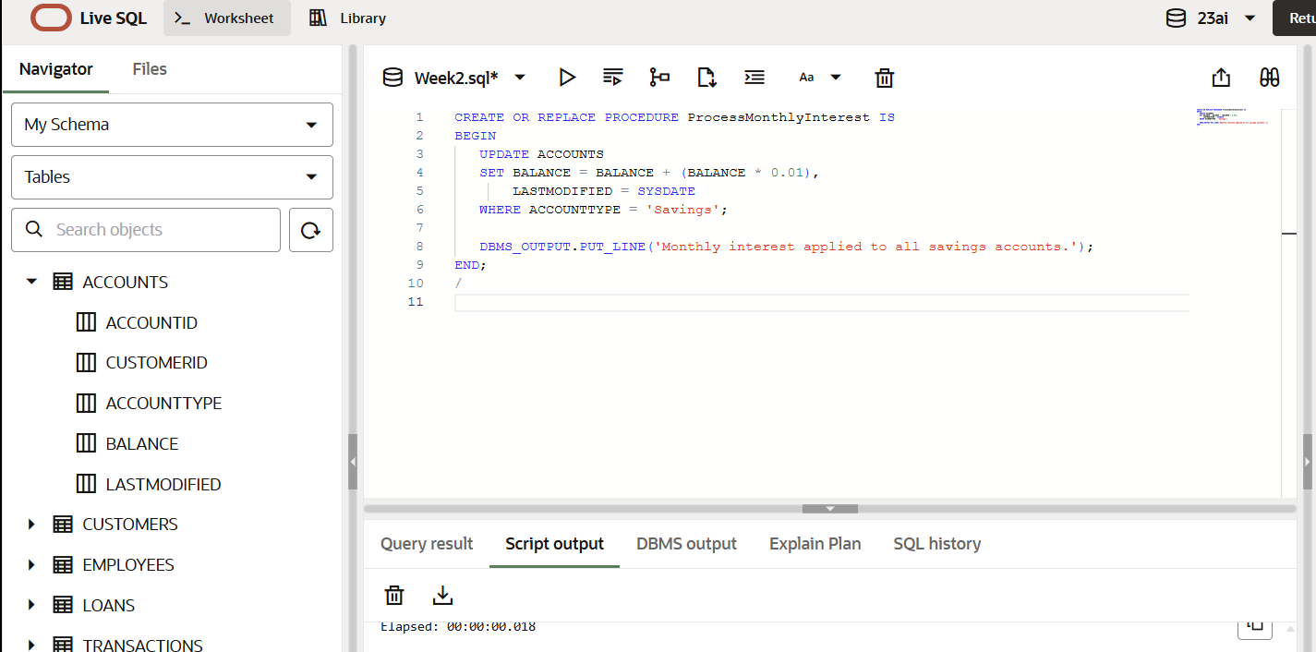

OUTPUT:  
  
  
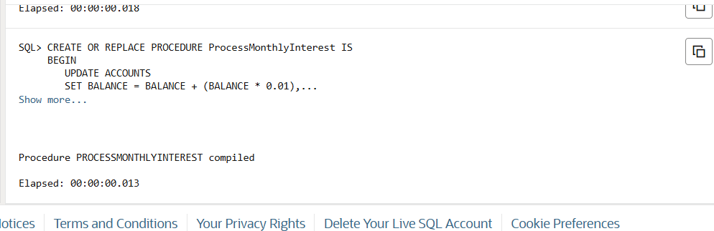

**Scenario 2:** The bank wants to implement a bonus scheme for employees based on their performance.

* + **Question:** Write a stored procedure **UpdateEmployeeBonus** that updates the salary of employees in a given department by adding a bonus percentage passed as a parameter.

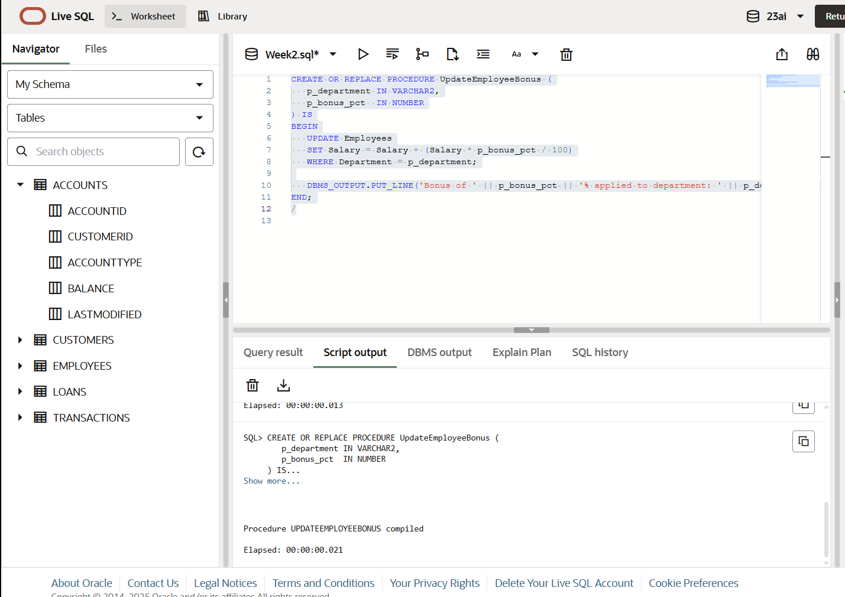

BEGIN

UpdateEmployeeBonus('IT', 10);

END;

/

**Scenario 3:** Customers should be able to transfer funds between their accounts.

* + **Question:** Write a stored procedure **TransferFunds** that transfers a specified amount from one account to another, checking that the source account has sufficient balance before making the transfer.

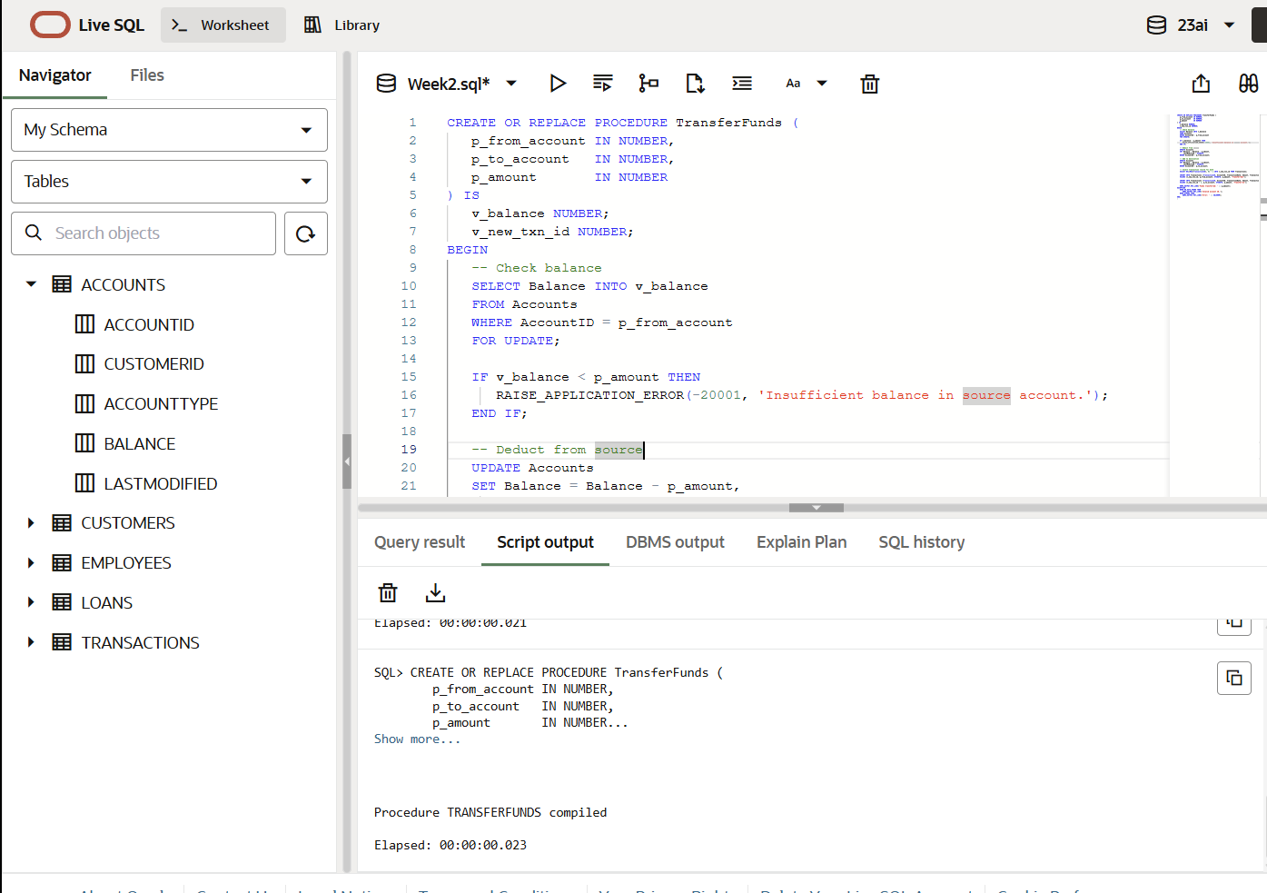

CREATE OR REPLACE PROCEDURE TransferFunds (

   p_from_account IN NUMBER,

   p_to_account   IN NUMBER,

   p_amount       IN NUMBER

) IS

   v_balance NUMBER;

   v_new_txn_id NUMBER;

BEGIN

   -- Check balance

   SELECT Balance INTO v_balance

   FROM Accounts

   WHERE AccountID = p_from_account

   FOR UPDATE;

   IF v_balance < p_amount THEN

      RAISE_APPLICATION_ERROR(-20001, 'Insufficient balance in source account.');

   END IF;

   -- Deduct from source

   UPDATE Accounts

   SET Balance = Balance - p_amount,

       LastModified = SYSDATE

   WHERE AccountID = p_from_account;

   -- Add to destination

   UPDATE Accounts

   SET Balance = Balance + p_amount,

       LastModified = SYSDATE

   WHERE AccountID = p_to_account;

   -- Insert transaction record for both

   SELECT NVL(MAX(TransactionID), 0) + 1 INTO v_new_txn_id FROM Transactions;

   INSERT INTO Transactions (TransactionID, AccountID, TransactionDate, Amount, TransactionType)

   VALUES (v_new_txn_id, p_from_account, SYSDATE, p_amount, 'Transfer-Out');

   INSERT INTO Transactions (TransactionID, AccountID, TransactionDate, Amount, TransactionType)

   VALUES (v_new_txn_id + 1, p_to_account, SYSDATE, p_amount, 'Transfer-In');

   DBMS_OUTPUT.PUT_LINE('Funds transferred: ' || p_amount);

EXCEPTION

   WHEN NO_DATA_FOUND THEN

      DBMS_OUTPUT.PUT_LINE('Invalid account ID.');

   WHEN OTHERS THEN

      DBMS_OUTPUT.PUT_LINE('Error: ' || SQLERRM);

END;

/